**Analysis of Students’ Final Exam Performance**

**Max Byrne, Paola Estrada Contreras**

**STAT301 Final Project**

**Spring 2025**

**Introduction**

The dataset used in this analysis was accessed from Kaggle.com. The dataset contained the scores of students' final exam scores (Exam_Score) along with various factors that may have affected the scores. Factors in this dataset include information like attendance, access to resources, hours of sleep and many others. Final exam scores were the dependent variable; this is numeric. One independent variable chosen for analysis included motivation level (Motivation_Level), a categorical variable with 3 levels: Low, Medium and High. Teacher quality (Teacher_Quality) was also used as an independent variable. It is a categorical variable with 3 levels: Low, Medium and High. The main effects and interaction between these variables were analyzed to answer the following questions:

How does motivation level affect final test scores?

H0: µLow = µMedium = µHigh

Ha: at least two of the means are significantly different

How does teacher quality affect final test scores?

H0: µLow = µMedium = µHigh

Ha: at least two of the means are significantly different

Is there a significant interaction between motivation level and teacher quality on final test scores?

H0: There is no significant interaction between motivation level and teacher quality

Ha: There is a significant interaction between motivation level and teacher quality

**Methods**

Two-way ANOVA was chosen for this analysis. The main effects of motivation level and teacher quality were investigated along with the interaction of the two independent variables. This analysis was chosen since we were interested in the two categorical independent variables and the interaction between them. Each independent variable has more than 2 levels. A two-way ANOVA was chosen versus a one-way ANOVA to increase the confidence level. Some of the teacher quality data was missing—the 78 entries without the teacher quality data were removed before moving on to the analysis. After the two-way ANOVA, a TukeyHSD test was performed to see if there was a significant difference in mean exam score between the three levels in each independent variables.

**Conclusion**

|  |  |  |
| --- | --- | --- |
| Table 1. F-statistic and p-value for the main effects and interaction term | | |
|  | F-statistic | P-value |
| Motivation Level | 26.285 | 4.27e-12 |
| Teacher Quality | 20.404 | 1.47e-9 |
| Motivation Level*Teacher Quality | 1.257 | 0.284 |

Main effects for motivation level

F-statistic: 26.285, p-value: 0

At a 0.05 significance level, we reject the null hypothesis. There is enough evidence to conclude that there is a significant difference among the different motivation levels.

Main effects for teacher quality

F statistic: 20.404, p-value: 0

At a 0.05 significance level, we reject the null hypothesis. There is enough evidence to conclude that there is a significant difference among the different teacher quality levels.

Interaction between motivation level and teacher quality

F-statistic: 1.257, p-value: 0.284

At a 0.05 significance level, we fail to reject the null hypothesis. There is not enough evidence to conclude that there is a significant interaction between motivation level and teacher quality level.

Figure 1. Interaction Plot for Motivation Level and Teacher Quality

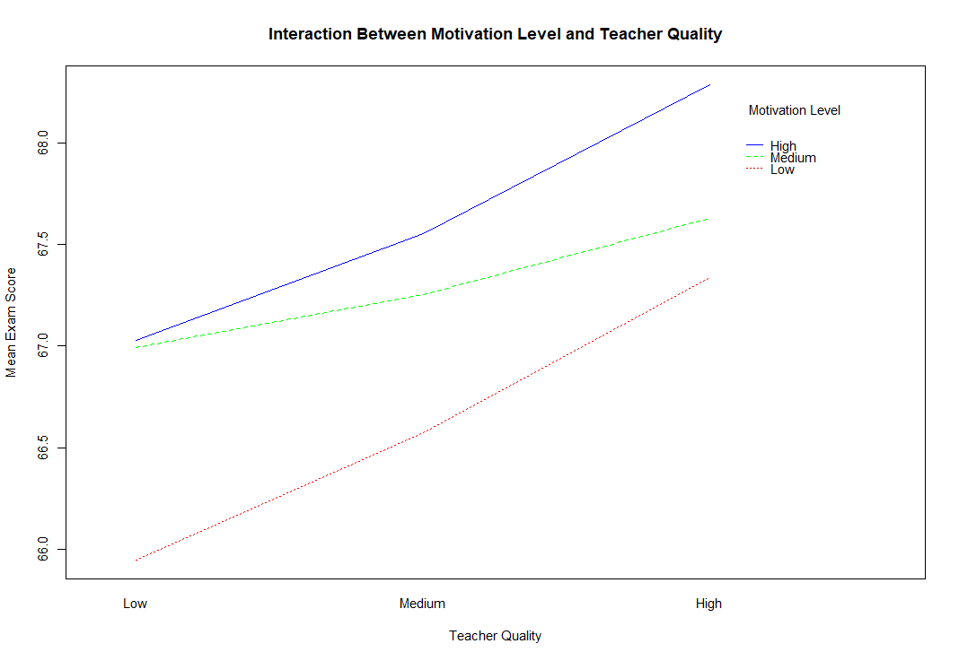

It was interesting that even though the effects of motivation levels and teacher quality were statistically significant, the interaction between the two variables was not. We would have thought that having a teacher of lower quality would contribute to lower motivation levels of the students. It is likely that the students’ motivation is linked to factors other than just the teacher’s quality.

After analysis of the two-way ANOVA results, a TukeyHSD test was performed on the two independent variables with the results shown below.

|  |  |  |
| --- | --- | --- |
| Table 2. TukeyHSD Test Results for Motivation Level | | |
|  | Difference | P-value |
| Medium-Low | 0.58 | 5.72e-7 |
| High-Low | 0.97 | 7.21e-9 |
| High-Medium | 0.39 | 5.63e-3 |

The TukeyHSD test for motivation level showed that all comparisons were statistically significant. Highly motivated students scored significantly higher than both medium and low motivated students, and students with medium motivation scored significantly higher than students with low motivation.

|  |  |  |
| --- | --- | --- |
| Table 3. TukeyHSD Test Results for Teacher Quality | | |
|  | Difference | P-value |
| Medium-Low | 0.39 | 4.14e-2 |
| High-Low | 0.96 | 1.33e-7 |
| High-Medium | 0.56 | 4.95e-7 |

The TukeyHSD test for teacher quality also showed that each comparison was significant. Having a high-quality teacher correlated with students having significantly higher exam scores compared to having a medium or low-quality teacher. While students with medium-quality teachers scored significantly better than students with low-quality teachers.

Overall, the analysis showed that both motivation level and teacher quality have a significant impact on how well students perform on exams, while the interaction between variables was not significant. Although the findings were significant, there are some limitations to consider. For example, it is not known how the categorical variables' levels were determined. The difference between high and medium quality or motivation is not necessarily consistent across all cases. Additionally, there are many other factors that could impact exam performance, such as family environment, personal study habits, or access to outside resources. Testing only teacher quality and motivation level does not provide a complete picture of why a student received a particular exam score. Even with these limitations, the results clearly show the role that student motivation and teacher quality play in academic outcomes.

[Paola Github Link](https://github.com/PaolaEC)

[Max Github Link](https://github.com/Max-Byrne/STAT301-Final-Project)